Information for University of Birmingham on campus activities
We look forward to welcoming you onto campus at the University of Birmingham. This document includes key information regarding your visit.

Venue Locations
Venue Name | Sports located at Venue | Address | what3words | Walking route from North Gate to location | Changing Room facilities
Sport and Fitness | All indoor sports including Swimming | Bristol Rd, Edgbaston, Birmingham B15 2TT | ///moves.gave.timing | 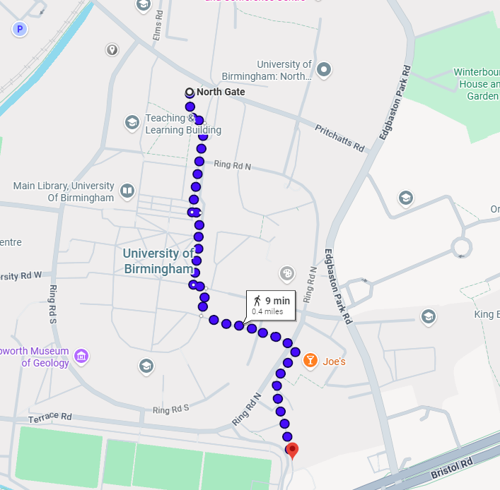  https://maps.app.goo.gl/MZtzUTuSVF9FAk9B7 | Arrive at Sport and Fitness Reception where you’ll be directed to changing rooms.
Bournbrook 3G Water Synthetics Tennis Courts | American Football  Hockey  Lacrosse  Football  Rugby (League and Union)  Tennis | Terrace Road, B15 2GR | ///tent.cans.ruled | 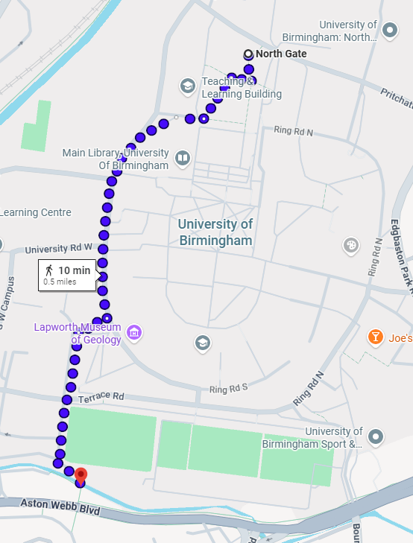  https://maps.app.goo.gl/45qsRwfxYZHZQsbi6 | Arrive at Bournbrook Pavilion
Metchley 3G | Football  Lacrosse  Rugby Union (League and Union)  Ultimate Frisbee | Metchley Park Road, B15 2TG | ///winner.grand.warm | 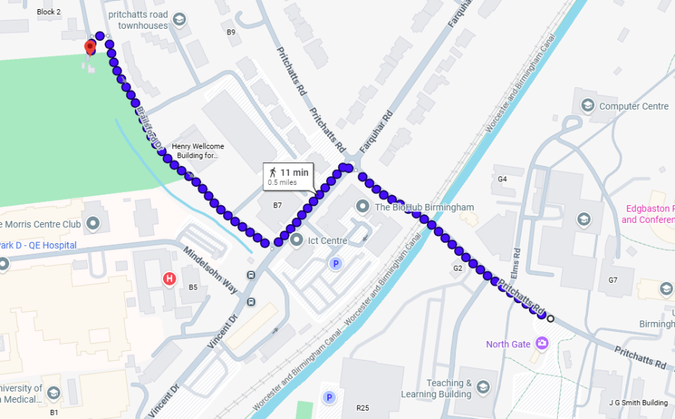  https://maps.app.goo.gl/LzvNEkH1gf7BuRto9 | Changing rooms are at the Metchley pitches
Metchley Grass Pitches |  | Metchley Park Road, B15 2TG | ///laying.hats.shape |  | Changing rooms are at the Metchley pitches

Please Note: Students will not be able to leave their belonging in changing rooms for their fixtures. Please advise them to keep belongs with them at all times. Individual Lockers are available in Bournbrook Pavillion and Bournbrook 3G that can be secured with an individual padlock. Visitors can purchase padlocks from Bournbrook Pavillion vending machine.

Parking Information
- Coach and Minibus Parking - All coaches and minibuses should park at North Gate Car Park (B15 2SA), which is located within a 10–20-minute walk of all sports facilities
  - If required, teams may be dropped off on campus; however, all vehicles must be relocated immediately to North Gate Car Park (or an overflow car park if directed by event staff).
  - Metchley 3G Pitches - There is insufficient space for coaches to turn around at the 3G pitch site. Coaches should therefore drop off passengers nearby, use one of the designated turning areas, and then proceed to North Gate Car Park.
  - External Gymnastics Facility Parking - Please ensure all club members are aware that parking at the Gymnastics Facility is not permitted. Vehicles parked there may be subject to parking enforcement charges.
- Car Parking for Visitors - All visitors to use the Northeast Multi-Storey Car Park, Pritchatts Road (B15 2SA). Parking charges are as follows:
  - Monday to Friday: £3.50–£11.00
  - Weekends: £3.50
- Parking payments can be made via the RingGo app (Location Code: 15677) or at the payment machines located on Floors 1 to 5 of the multi-storey car park.
- Officials should speak with the host club regarding discounted parking rates where applicable.
- For further travel information and campus directions, please visit:
https://www.birmingham.ac.uk/contact/directions/getting-here-edgbaston
Venue Specific Information
- Alcohol - is permitted within outdoor sports facilities and not permitted within indoor facilities provided it is consumed responsibly and in accordance with venue regulations. To ensure the safety of all participants and spectators, alcohol must not be brought into or consumed from glass containers or onto any playing surface. Please ensure that all players, coaches, officials, and spectators are aware of and comply with this requirement.
- Photography and Live Streaming - Fixtures may be live streamed, and photography and videography may be undertaken by university staff and student ambassadors. Content may be used across University of Birmingham Sport communication channels, including social media platforms. If any member of your team does not consent to being photographed or filmed, please notify us in advance by emailing our Marketing team at press@sportandfitness.bham.ac.uk.Or inform the team coach or event organiser before the fixture begins. The club will take all reasonable steps to ensure your image is not captured or published.
- Use of Unmanned Aerial Vehicles (UAVs) - Teams wishing to operate a UAV (Unmanned Aerial Vehicle) in connection with a fixture or event at University of Birmingham sports facilities must obtain prior approval. Please contact Steve Harris, UBSport and Fitness Health & Safety Officer (s.a.harris@bham.ac.uk | 07770 703466) at least three weeks before your visit. Approval will be subject to verification of the appropriate training, qualifications, and insurance documentation required for UAV operation.

