HOW TO BOOK ONTO CAMPUS LEAGUE – TERM 1 (2022/23)

Login to the online booking system here: Online Booking (bham.ac.uk)
You’ll find the calendar function on the ‘welcome page’ – you need to type in the date of the first fixture of the league you want to enter.

The date of first fixtures can be found on the Campus League website here: Campus League - University of Birmingham Sport & Fitness (bham.ac.uk)

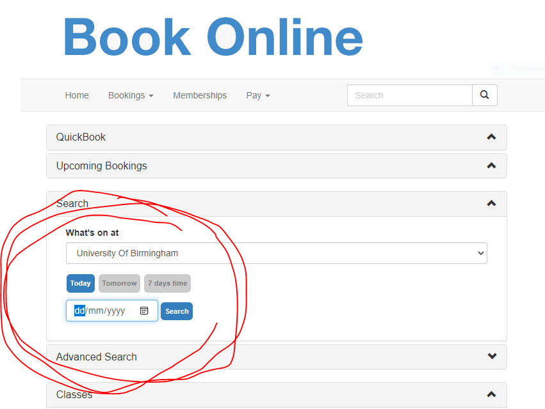

For example, I will look up Friday 7th October to enter the 1pm 6-a-side league.
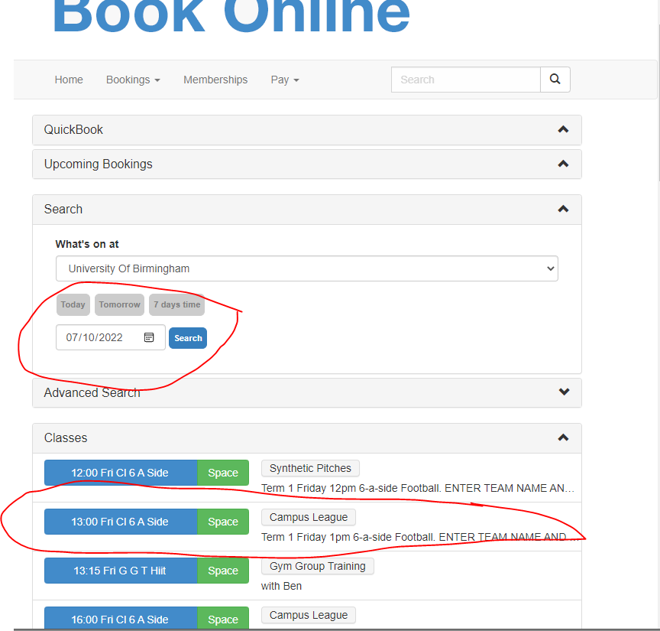
Then, click on the league and this is where you will pay entry to the league for the whole term for your team.
